8.2 Maintaining children’s safety and security on premises
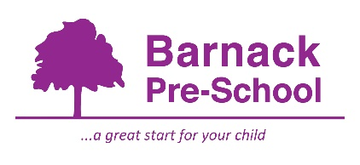
Policy statement

We maintain the highest possible security of our premises to ensure that each child is safely cared for during their time with us.

Procedures

Children's personal safety

We ensure all employed staff have been checked for criminal records via an enhanced disclosure with children’s barred list check through the Disclosure and Barring Service.

Adults do not normally supervise children on their own.

All children are supervised by adults at all times.

Whenever children are on the premises at least two adults are present.

We carry out risk assessments to ensure children are not made vulnerable within any part of our premises, nor by any activity.

Security
- Systems are in place for the safe arrival and departure of children.
- The times of the children's arrivals and departures are recorded.
- The arrival and departure times of adults – staff, volunteers and visitors - are recorded.
- Our systems prevent unauthorised access to our premises.
- Our systems prevent children from leaving our premises unnoticed.
- We only allow access to visitors with prior appointments.
- Our staff check the identity of any person who is not known before they enter the premises.
- We keep front doors and gates locked shut at all times. Back doors are kept locked shut at all times where they may lead to a public or unsupervised area.
- The personal possessions of staff and volunteers are securely stored during sessions.
- Minimal petty cash is kept on the premises.

This policy was adopted by | Barnack Pre-School | (name of provider)
On | January 2021 | (date)
Date to be reviewed | January 2022 | (date)
Signed on behalf of the provider
Name of signatory | Kirsty Adams
Role of signatory | Manager

Other useful Pre-school Learning Alliance publications

- Managing Risk (2009)

