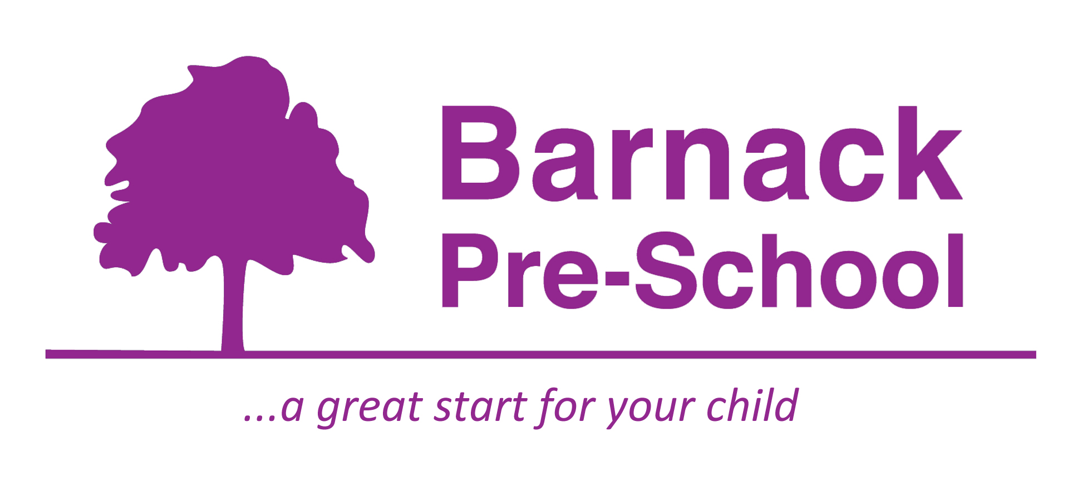

Emergency Lockdown Procedures Policy
Barnack Pre-school recognises the potentially serious risks to children, staff and visitors in emergency or harmful situations. A lockdown may take place where there is a perceived risk of threat to the pre-school, its staff, children, visitors or property.
A lockdown will be initiated by a member of staff blowing the whistle to gather all the children together and take them inside the building as quickly as possible. Kirsty Adams (Manager) or Helen Holroyd (Deputy manager) will immediately call 999 and if appropriate the Chairperson.
Lockdown procedures- Staff will move the children out of sight to the office and close the door taking the pre-school mobile phone and register. Deputy manager or room lead will complete a head count of children whilst the Manager/ Deputy manager quickly checks the premises for any other children. Staff will secure all windows and doors and close the curtains and blinds. Everyone will remain out of sight until further instructions are received from the emergency services. The staff will attempt to keep the children as quiet and calm as possible until the dangerous situation is over.
Once the danger has passed, when we are completely sure that the danger is over, we will leave our safe place and continue our activities as far as possible.
The manager/ deputy manager will phone the parents/carers and the chairperson (if not already contacted), to inform them of the incident. Records will be made of the event and actions taken will be recorded in our incident book. Ofsted and Early years will be informed within 24 hours of the incident occurring.

This policy was adopted by | Barnack Pre-School
On | February 2020 | (date)
Date to be reviewed | February 2021 | (date)
Signed on behalf of the provider
Name of signatory | Kirsty Adams
Role of signatory | Manager

