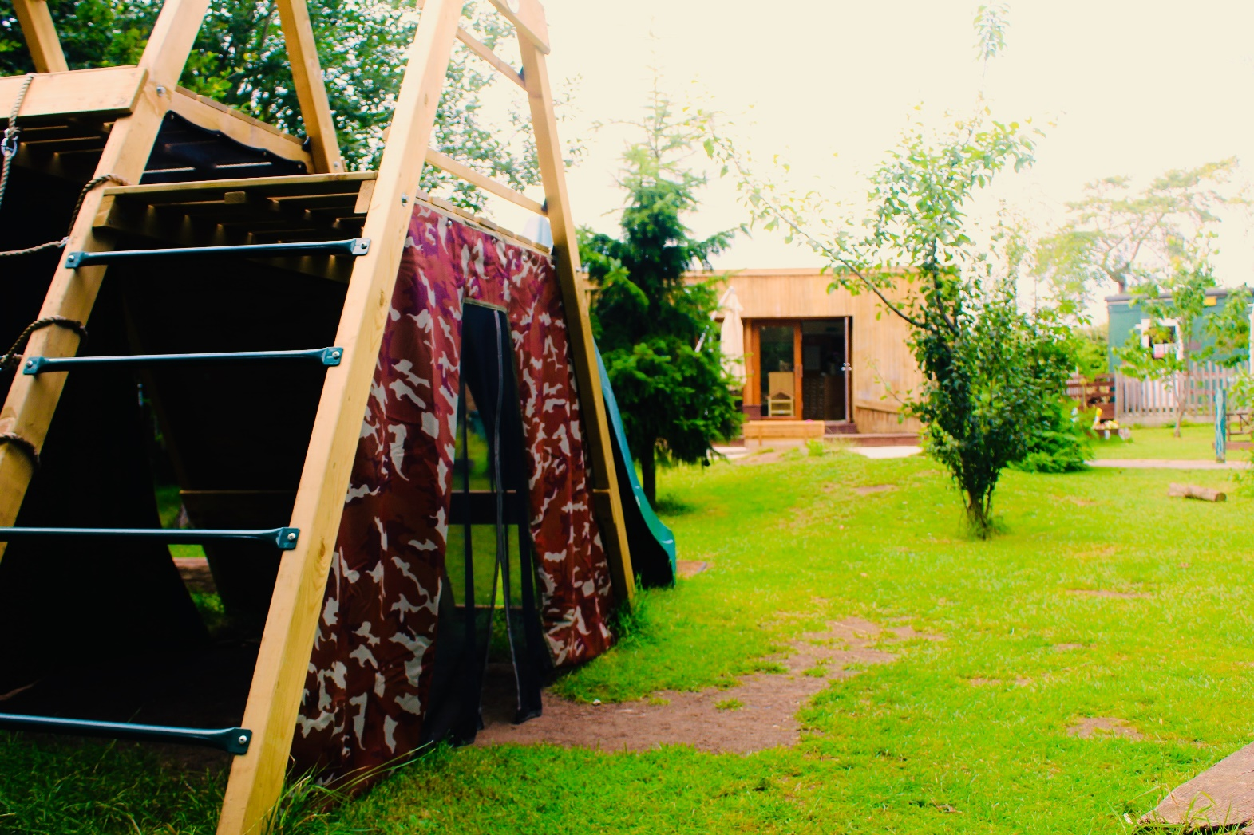
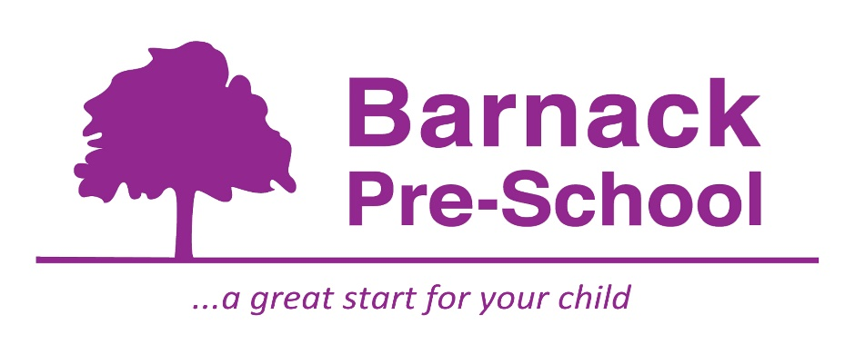
Welcome Book

Welcome
We would like to welcome you to Barnack Pre-School, and hope you find this booklet helpful. If you have any questions that are not answered here, please feel free to contact us on the details given on the back page.

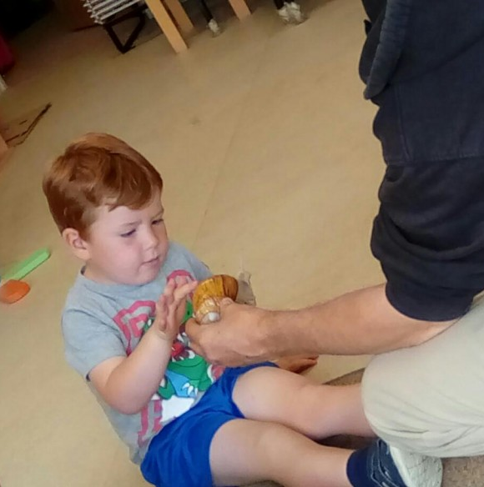

Our Mission Statement
Barnack Pre-school aims to provide a great start for your child by offering appropriate play, education and care facilities in our warm and nurturing environment.

Times
The pre-school is available to children from 2.5 years old, Monday to Friday, at the following session times:
9am-12pm
12pm-3pm
9am-1pm
9am-3pm
We can also offer provision for children to start at the earlier time of 8:30 and the slightly later collection time of 3:30pm.
Pre-School is term time only. The terms run in line with Barnack C of E Primary School. (Please see our annual term dates at the back of the folder.)
If your child is unable to attend pre-school due to illness, please give us a call or send an email to the details given on the back page. If your child is going to be absent due to a holiday, please let us know in advance.

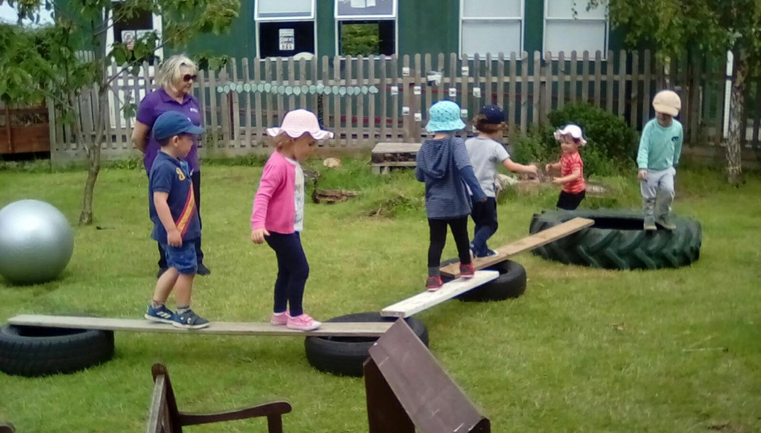

Fees
Pre-School fees are £6.00 an hour. Every half term, parents will receive an invoice detailing the amount owing for all sessions their child will be attending during the term.
The invoice will be sent out during the second week of each term. It will state the date by which payment in full must be made.
Payment of fees can be made by either;
- BACS send to Barclays
Sort code: 20-81-20
Account number: 03291006
- Childcare vouchers- Please check with Kirsty what voucher companies we can offer.
If the fees are not received by the due date, the pre-school will immediately issue a reminder to the parent/carer in writing, providing a deadline for payment.
Late collection fees: A late collection fee will apply at the Managers discretion when the booked session has ended, and your child has not been collected. This is £6.00 per 15 minutes.
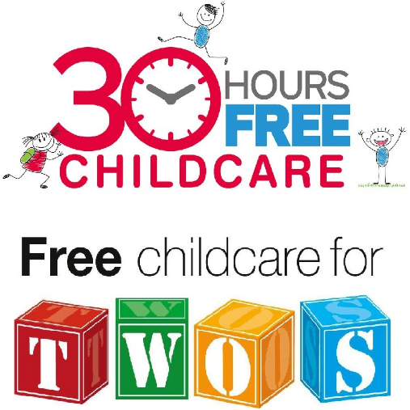
Early years government funding is available for all 3- and 4-year olds, the term after their 3rd Birthday.
If both parents/carers are working parents, you may be entitled to 30 hours of free childcare.
If you are claiming specific benefits, you may be entitled to 15 hours free childcare, the term after your child’s 2nd Birthday.
Please speak to Kirsty for more information.

Mealtimes
Snacks
All children are provided with a varied and healthy snack. We have rolling snack, which means the snack table is open from 9:45-10:30am every day, and the children can come to the snack table when they want to and when they see a space is available. The children are offered milk or water. We provide the main part of snack, and parents/carers are on a rota to bring the fruit part in. We cater for any dietary requirements. Please make these known, by writing this information on the registration forms.

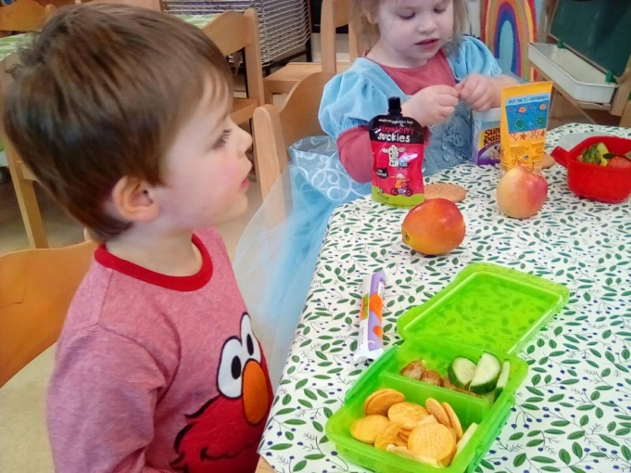
Lunch
Lunches are packed lunches provided by parents/carers. We recommend and encourage healthy eating. Therefore, we suggest a varied lunch box, offering items you know your children like. We are a nut free pre-school and we do not accept nuts into the setting. Due to choking hazards, we ask that grapes, olives and cherry tomatoes, are cut in half long ways.
We have started to have a hot lunch option, which is provided by the school kitchens. The meals are transported safely over to us at pre-school. The hot lunch is £2.00 per meal and is added to your monthly invoice. Menus are sent out monthly.
Drinks
To encourage children to drink plenty of fluids, we ask you to provide a fresh bottle of water (not juice) every day they attend. Please ensure these are named.
Please Provide..
To enable your child to fully enjoy their time with us, we ask you to provide (all named):

- Weather appropriate clothing
- Spare clothes
- Water bottle
- Wellies
- Sun cream (when applicable)

Where required:
- Nappies/ wipes/nappy bags, cream etc.
- Packed lunch in a named bag or box.

We encourage the children to wear our pre-school t-shirts. There is one provided within this pack, and additional ones can be purchased for £5.50. Please speak to Kirsty or Helen if this is of interest to you.

Parking
The pre-school is situated within the grounds of Barnack C of E Primary School. Parents/ carers are allowed to use the school car park to drop and collect your children from pre-school. Drop off and collection times are always quite hectic in terms of parking, so please allow yourselves extra time to park, parking effectively to fit more cars in. Please keep your speed down to 4mph.

Additional parking is available at the village hall or the Millstone pub.

Your Child
We are here to support and encourage your child and to work with you to settle in your child/children quickly and happily within our setting.
Settling in
- Home visits- We plan a visit with yourself before your child begins pre-school. Your child’s keyworker will spend time with your child, bringing a few conversation starters in a basket. Kirsty or Helen will then fill out an all about me form with yourselves to find out your child’s routines, likes and dislikes.
- The first visit to pre-school will be an hour’s visit with parental support. We then ask parents/carers to leave for an hour.
- Following on from there settling in visit, we will assess if your child is happy and relaxed to start their full sessions, or if they require more settling in visits. We cater these to their individual needs.
Key Person
Your child will be allocated a key person before their first visit. The key person approach gives every child the reassurance to feel secure and cared for, helping them to become familiar with the pre-school environment and to feel confident and safe within it. We recognise every child’s individuality, efforts and achievements and believe that relationships between adults and children are crucial for the child’s happiness and well- being.
Sickness and Accidents
Please contact pre-school if your child is unable to attend a session. If your child has sickness or diarrhoea, please leave a minimum of 48 hours after the last episode, before returning them to pre-school. If your child has had an accident at home or has any bumps or bruises, please just let us know so that we can keep an extra eye on them.
Wow Moments
“Wow” are a way to celebrate your child’s achievements within pre-school. We feel this is a positive way to bind and celebrate the home/school relationship with your child.
The completion of “Wow moments” can be undertaken by parents, carers, grandparents, relatives and childminders.
Wow moments will also be completed in pre-school as well and added to our “wow moments board” inside the pre-school. They will be added to your child’s learning journal and the information we gather from them are a valuable source of evidence when completing your child’s learning journal.
Examples of Wow moments, could be;
- Being helpful
- Riding a bike for the first time
- Sleeping all night
- Trying new foods.
- Toilet training
Tapestry
We use an interactive learning journal called Tapestry within the pre-school. You will be able to access Tapestry allowing you to be involved within your home.
Observations are carried out within the pre-school by using an iPad or tablet. A key worker will carry out an observation, and then during their set key time every week, the keyworker will assess and publish them for you to view.
You also have the opportunity to add any photographs from special times to the learning journal. Children are constantly learning through their play and experiences. You also have the opportunity to comment on the observations made by practitioners. This is a great tool for parental involvement. Please be assured this is safe and secure and only the people who have access to your child’s journal are staff and yourselves.
Learning
All practitioners observe all children in the setting daily, using a variety of both written and photographic observations. If a child is aged between 2 and 3, we will also complete a progress check, in line with your health visitors 2- year check.
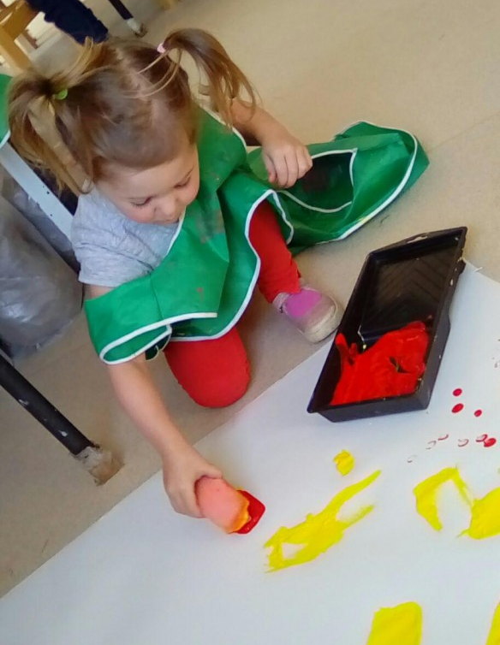
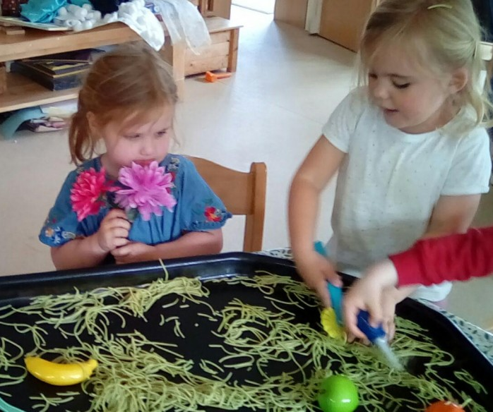

All observations are shared with the parents/carers and help to obtain a clear picture of the child’s needs and how to plan at both the setting and at home. Our planning is reflected on every child’s interests and gives opportunities for your child to make progress towards their next steps.

It is crucial we discuss, share and involve parents, as you know your child best! By doing so, we can obtain a full, rounded picture of your child and helps us understand how we can support their development with the co-operation and understanding of all parents. We share this information with you by adding their next steps to Tapestry and also having termly parent consultations. We also meet with you to share with you your child’s summary 2, a report which is passed onto your chosen primary school in the summer term.

Each of the seven areas of learning and development are broken into the following age bands; birth- 11 months, 8-20 months, 16-26 months, 22-36 months, 30-50 months and 40-60 months, including Early learning goals. You will notice on Tapestry, these age bands are mentioned on their observations. This is to help plot your child’s development, but please note the age bands are guidelines only and not fixed, with many children over-lapping several stages. The EYFS guidance is also used by schools during your child’s reception year.
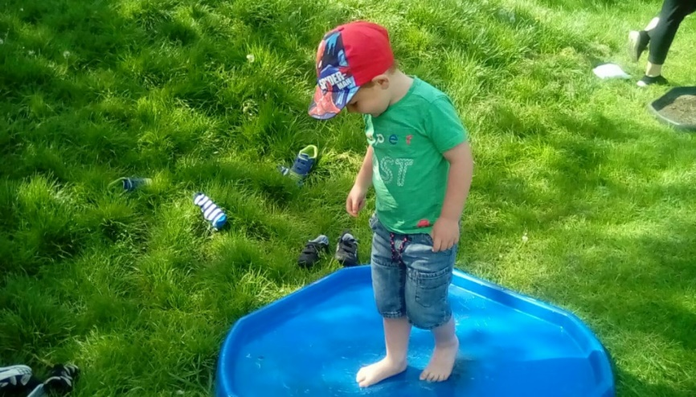

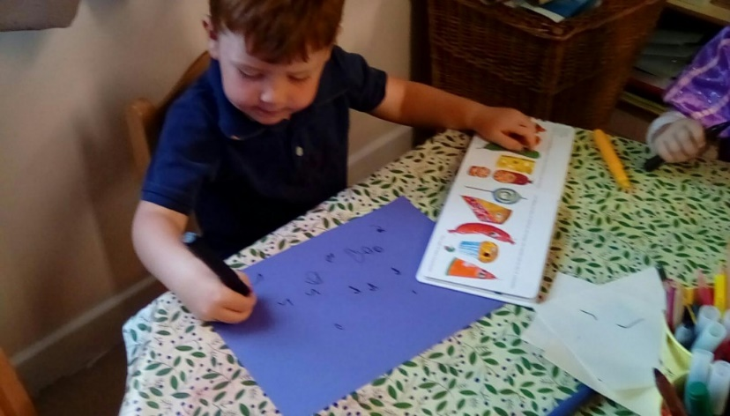
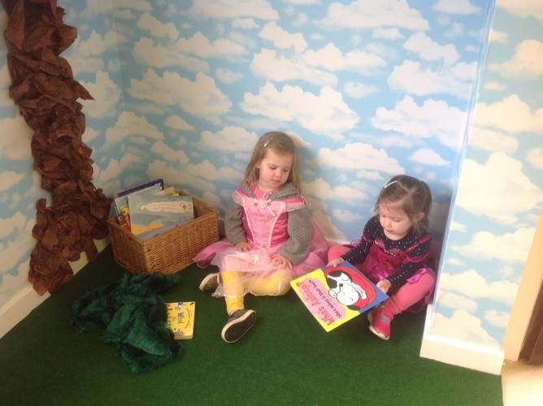

At Barnack Pre-School we are always available to discuss your child’s needs and development on the EYFS or how to plan and observe, please feel free to talk to us or make an appointment.

Data Protection
Information we hold about you and your child:
We have procedures in place for the recording and sharing of information about you and your child that is compliant with the principles of the General Data Protection Regulations (2018) as follows:

The data we collect is:
- Processed fairy, lawfully and in a transparent manner in relation to the data subject (you and your family)
- Collected for specified, explicit and legitimate purposes and not further processed for other purposes incompatible with those purposes.
- Adequate, relevant and limited to what is necessary in relation to the purposes for which data is processed.
- Accurate and, where necessary, kept up to date.
- Kept in a form that permits identification of data subjects (you and your family) for no longer than is necessary for the purposes for which the personal data is processed.
- Processed in a way that ensures appropriate security of the personal data including protection against unauthorised or unlawful processing and against accidental loss, destruction ort damage, using appropriate technical or organisational measures.
When you register your child with us, we will provide you with a privacy notice that gives you further details of how we fulfil our obligations with regard to your data.

Safeguarding
Safeguarding children
Our setting has a duty under the law to help safeguard children against suspected or actual ‘significant harm.’ Our employment practices ensure children against the likelihood of abuse in our setting and we have a procedure for managing complaints or allegations against staff members.
Our way of working with children and their parents ensures that we are aware of any problems that may emerge and can offer support, including referral to appropriate agencies when necessary, to help families in difficulty.
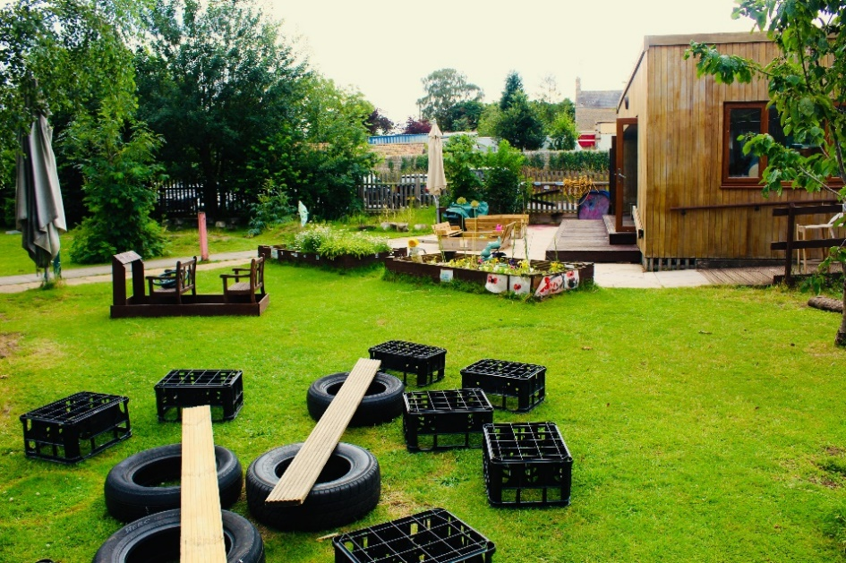
You can find our whistleblowing policy and how to make a complaint in our policy folder that is accessible to parent’s in the cloakroom.

Additional needs
To make sure that our provision meets the needs of each individual child, we take account of any additional needs a child may have. We work to the requirements of the special educational needs and disability code of practice: 0-25 years (2015).
Our special educational needs coordinator (SENCO) is: Kirsty Adams.

Policies
Our staff can explain our policies and procedures to you. Copies of which are available in the pre-school cloakroom and on our website.

Our policies help us to make sure that the service provided by our setting is a high quality one and that being a member of the setting is an enjoyable and beneficial experience for each child and her/ his parents.

Our staff and parents work together to adopt the policies and they all have the opportunity to take part in the annual review of the policies. This review helps us to make sure that the policies are enabling our setting to provide a quality service for its members and the local community.

Complaints: If you would like to make a complaint, please contact out manager at the pre-school in the first instance, or if you would prefer, you can contact the chair of our committee.

Weekly Updates
We issue a Weekly Update for pre-school. Within the update we give you an overview of the past week’s activities and details of planned activities for next week. It also includes reminders for parents, along with important news or dates for your diary. These are emailed to you every Friday.

Committee
Charity
Barnack Pre-School is a registered charity and is managed, in addition to the amazing team, by a committee of volunteers. All volunteers are parents or carers with an interest in making the pre-school as successful as possible.

Each member is voted in each year at Annual General Meeting that usually takes place in September.
The key roles are:
Chairperson
Secretary
Treasurer.

We also require additional members to help with fundraising. New members are welcome whether to take on a key role or a supportive one and are essential in the long-term success of pre-school.
Fundraising
Each year the committee organises a number of fundraising events. These events enable the pre-school to fund for some of the more special things. Previous fundraising has helped us to purchase, tablets for the educational purposes for the children, renovating our book corner, our climbing frame and sand pits, to name just a few.

Please look out for upcoming events as your support is vital! Thank you in advance.

Useful Contacts
Barnack Pre-School
School Lane,
Barnack,
Stamford,
PE9 3DZ

Telephone Number: 01780 749355

Please visit out Facebook page Barnack Pre-School and Wrap Around Care.

Our Website is currently under construction.

Other useful contacts:
Barnack C of E Primary School- 01780 740265
http://www.barnackprimaryschool.co.uk/
www.peterborough.gov.uk
www.gov.uk/early-years-foundation-stage
www.ofsted.gov.uk
www.pre-school.org.uk

