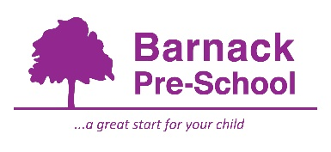04 Health policy

Alongside associated procedures in 04.1-04.7 Health, this policy was adopted by Barnack Pre-School on22nd January 2025.

Aim
Our provision is a suitable, clean, and safe place for children to be cared for, where they can grow and learn. They meet all statutory requirements for promoting health and hygiene and fulfil the criteria for meeting the relevant Early Years Foundation Stage Safeguarding and Welfare requirements.
Objectives
We promote health through:
- ensuring emergency and first aid treatment is given where necessary
- ensuring that medicine necessary to maintain health is given correctly and in accordance with legal requirements
- identifying allergies and preventing contact with the allergenic substance
- identifying food ingredients that contain recognised allergens and displaying this information for parents
- promoting health through taking necessary steps to prevent the spread of infection and taking appropriate action when children are ill
- promoting healthy lifestyle choices through diet and exercise
- supporting parents right to choose complementary therapies
- pandemic flu planning or illness outbreak management as per DfE and World Health Organisation (WHO) guidance
Legal references
Medicines Act (1968)
Reporting of Injuries, Diseases and Dangerous Occurrences Regulations 2013 (RIDDOR)
Control of Substances Hazardous to Health (COSHH) Regulations (2002)
Health and Safety (First Aid) Regulations 1981
Food Information Regulations 2014
Further guidance
Accident Record (Alliance Publication)

