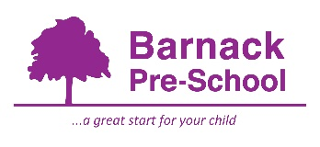04. Health procedures
04.6 Oral health
The setting provides care for children and promotes health through promoting oral health and hygiene, encouraging healthy eating, healthy snacks and tooth brushing.
- Fresh drinking water is always available and easily accessible.
- Sugary drinks are not served.
- Only water and milk are served with morning and afternoon snacks.
- Children are offered healthy nutritious snacks with no added sugar.
- Parents/carers are discouraged from sending in confectionary as a snack or treat.
- Staff follow the Infant & Toddler Forum’s Ten Steps for Healthy Toddlers.
Where children clean their teeth when at the setting
- Children are encouraged to brush their teeth as part of the daily routine at home. Teeth should not be cleaned for at least one hour after a meal as this can cause loss of enamel.
- Oral hygiene activities are included in planning at least every three months where each child has their own toothbrush and children practice in front of a mirror, showing them how to brush their teeth.
Pacifiers/dummies
- If a child starts with us and uses a dummy, although our children start from 2 years, Parents/carers are advised that the use of dummies/pacifiers should be stopped from 12 months old.
- Dummies that are damaged are disposed of and parents/carers are told that this has happened
Further guidance
Infant & Toddler Forum: Ten Steps for Healthy Toddlers www.infantandtoddlerforum.org/toddlers-to-preschool/healthy-eating/ten-steps-for-healthy-toddlers/

