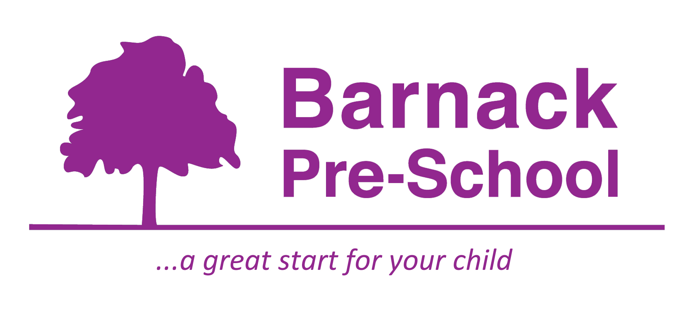06 Safeguarding children, young people and vulnerable adults procedures
06.2 Concerns and allegations of serious harm or abuse against staff, volunteers or agency staff
Concerns may come from a parent/carer, child, colleague, or the public. Allegations or concerns must be referred to the designated safeguarding lead person without delay - even if the person making the allegation later withdraws it.
What is a low-level concern?
The NSPCC defines a low-level concern as ‘any concern that an adult has acted in a way that:
- is inconsistent with the staff code of conduct, including inappropriate conduct outside of work
- doesn’t meet the threshold of harm or is not considered serious enough…to refer to the local authority.
Low-level concerns are part of a spectrum of behaviour. This includes:
- inadvertent or thoughtless behaviour
- behaviour that might be considered inappropriate depending on the circumstances.
- behaviour which is intended to enable abuse.
Examples of such behaviour could include:
- being over friendly with children
- having favourites
- adults taking photographs of children on their mobile phone.
- engaging with a child on a one-to-one basis in a secluded area or behind a closed door
- using inappropriate sexualised, intimidating or offensive language’
(NSPCC Responding to low-level concerns about adults working in education)
Responding to low-level concerns
Any concerns about the conduct of staff, students or volunteers must be shared with the designated safeguarding lead and recorded. The designated safeguarding lead should be informed of all concerns, including those that may initially be considered ‘low level’ and make the final decision on how to respond. Where appropriate this can be done in consultation with their line manager.
Reporting concerns about the conduct of a colleague, student or volunteer contributes towards a safeguarding culture of openness and trust. It ensures that adults consistently model the setting’s values and helps keep children safe. It protects adults from potential false allegations or misunderstandings.
If it is not clear that a concern meets the local authority threshold, the designated safeguarding lead should contact the LADO for clarification.
In most instances, low-level concerns about staff conduct can be addressed through supervision, training, or disciplinary processes where an internal investigation may take place.
Identifying
An allegation against a member of staff, volunteer or agency staff constitutes serious harm or abuse if they:
- behaved in a way that has harmed, or may have harmed a child
- possibly committed a criminal offence against, or related to, a child
- behaved towards a child in a way that indicates they may pose a risk of harm to children
- behaved or may have behaved in a way that indicates they may not be suitable to work with children
Informing
- All staff report allegations to the designated safeguarding lead.
- The designated safeguarding lead alerts the designated officer for their setting. If the designated officer is unavailable the designated person contacts their equivalent until they get a response- which should be within 3-4 hours of the event. Together they should form a view about what immediate actions are taken to ensure the safety of the children and staff in the setting, and what is acceptable in terms of fact-finding.
- It is essential that no investigation occurs until and unless the LADO has expressly given consent for this to occur, however, the person responding to the allegation does need to understand what explicitly is being alleged.
- The designated safeguarding lead must take steps to ensure the immediate safety of children, parents, and staff on that day within the setting.
- The LADO is contacted as soon as possible and within one working day. If the LADO is on leave or cannot be contacted the LADO team manager is contacted and/or advice sought from the point of entry safeguarding team/mash/point of contact, according to local arrangements.
- A child protection referral is made if required. The LADO, line managers and local safeguarding children’s services can advise on whether a child protection referral is required.
- The designated safeguarding lead asks for clarification from the LADO on the following areas:
- what actions the designated safeguarding lead must take next and when and how the parents/carers of the child are informed of the allegation
- whether or not the LADO thinks a criminal offence may have occurred and whether the police should be informed and if so, who will inform them

- whether the LADO is happy for the provider to pursue an internal investigation without input from the LADO, or how the LADO wants to proceed
- whether the LADO thinks the person concerned should be suspended, and whether they have any other suggestions about the actions the designated person has taken to ensure the safety of the children and staff attending the setting
- The designated safeguarding lead records details of discussions and liaison with the LADO including dates, type of contact, advice given, actions agreed and updates on the child’s case file.
- Parents/carers are not normally informed until discussion with the LADO has taken place, however in some circumstances the designated safeguarding lead may need to advise parents/carers of an incident involving their child straight away, for example if the child has been injured and requires medical treatment.
- Staff do not investigate the matter unless the LADO has specifically advised them to investigate internally. Guidance should also be sought from the LADO regarding whether suspension should be considered. The person dealing with the allegation must take steps to ensure that the immediate safety of children, parents/carers and staff is assured. It may be that in the short-term measures other than suspension, such as requiring a staff member to be office based for a day, or ensuring they do not work unsupervised, can be employed until contact is made with the LADO and advice given.
- The designated safeguarding lead ensures staff fill in 06.1b Safeguarding incident reporting form.
- If after discussion with the designated safeguarding lead, the LADO decides that the allegation is not obviously false, and there is cause to suspect that the child/ren is suffering or likely to suffer significant harm, then the LADO will normally refer the allegation to children’s social care.
- If notification to Ofsted is required the designated safeguarding lead will inform Ofsted as soon as possible, but no later than 14 days after the event has occurred. The designated safeguarding lead will liaise with the designated officer/line manager about notifying Ofsted.
- The designated safeguarding lead ensures that the safeguarding incident report form is completed and sent to the designated officer/line manager. If the designated officer is unavailable their equivalent must be contacted, for providers registered with a childminding agency, this may be the named person within the agency.
- Avenues such as performance management or coaching and supervision of staff will also be used instead of disciplinary procedures where these are appropriate and proportionate. If an allegation is ultimately upheld the LADO may also offer a view about what would be a proportionate response in relation to the accused person.
- The designated safeguarding lead must consider revising or writing a new risk assessment where appropriate, for example if the incident related to an instance where a member of staff has physically intervened to ensure a child’s safety, or if an incident relates to a difficulty with the environment such as where parents/carers and staff are coming and going, and doors are left open.
- All allegations are investigated even if the person involved resigns or ceases to be a volunteer.
Allegations against agency staff
Any allegations against agency staff must be responded to as detailed in this procedure. In addition, the designated person must contact the agency following advice from the LADO
Allegations against the designated safeguarding lead.
- If a member of staff has concerns that the designated person has behaved in a way that indicates they are not suitable to work with children as listed above, this is reported to the designated officer who will investigate further.
- During the investigation, the designated officer/line manager will identify another suitably experienced person to take on the role of designated safeguarding lead.
- If an allegation is made against the designated officer/line manager, then the owners/directors/trustees are informed.
Recording
- A record is made of an allegation/concern, along with supporting information. This is then entered on the file of the child, and the 06.1a Child welfare and protection summary is completed and placed in the front of the child’s file.
- If the allegation refers to more than one child, this is recorded in each child’s file
- If relevant, a child protection referral is made, with details held on the child’s file.
Disclosure and Barring Service
- If a member of staff is dismissed because of a proven or strong likelihood of child abuse, inappropriate behaviour towards a child, or other behaviour that may indicate they are unsuitable to work with children such as drug or alcohol abuse, or other concerns raised during supervision when the staff suitability checks are done, a referral to the Disclosure and Barring Service is made.
Escalating and whistleblowing concerns
- If a member of staff believes at any time that children may be in danger due to the actions or otherwise of a member of staff or volunteer, they must discuss their concerns immediately with the designated safeguarding lead.
- If after discussions with the designated safeguarding lead, they still believe that appropriate action to protect children has not been taken they must speak to the designated officer/line manager.
- If there are still concerns then the whistle blowing procedure must be followed, as set out in 06.1 Responding to safeguarding or child protection concerns.

